(Approx. 1,304 words)

DustKleenTM
by Neil Longmuir, Winnipeg PC User Group Inc.
http://www.wpcusrgrp.org/
longmur(at)ms.umanitoba.ca

Obtained from APCUG with the author's permission for publication by APCUG member groups.

Introduction
DustKleen is an innovative stand alone application from Image Trends Inc. DustKLeen will automatically remove most dirt and dust from any scanned images regardless of the source. The scanned images can be color, black and white negatives, color slides including Kodachrome or prints. The technology which is patent pending, identifies the dust or debris on the image. These “defects” are removed without destroying the image quality. DustKleen is exactly the type of innovative software that digital image users need who use a scanner to convert images to a digital format. DustKleen occupies 2.97 mb of hard disk space once it’s been installed.

Working with DustKleen
When was the last time you installed a stand alone program that used so little hard disk space? My test hardware is running XP Pro with an AMD 3200 processor, 1 Gig Dual Channel RAM, 320 gig of hard disk space on two hard drives, CD and DVD burners, ATI Radeon video card with 64 mb of RAM. Windows NT, 2000 and Vista operating systems are also supported. A Mac version is currently under development.

The software interface is clean and very easy to use. Press the ? on the bottom left of the program to get a quick overview of how to use DustKleen. Clicking on the ? will bring up more detailed help information. The help files are very well written and have all the information required to answer questions. Because DustKleen is a stand alone program it works very fast. DustKleen targets one real problem, dust and debris on scanned images, and does the job it was designed to do very well. DustKleen can read BMP, JPG, PNG, PSD and TIFF files.

The automatic detection and removal default setting works great for most images without any end user intervention. There will be times when the default settings do not clean up all of the dust or debris defects. However, the good news is that the default automatic detection and removal gives the end user three tools for removing dust and debris. These tools are: dust size, dust amount and dust aggression. Any additional defects can be handled using the advanced “Manual Touch Up” mode. The Manual Touch Up modes lets the end user adjust both brush and dust size to target a specific area of the image. The “Add Touch Up” feature works very similar to the healing brush in Adobe Photoshop and Adobe Photoshop Elements. If you do not like your change, pressing Ctrl+Z will remove it immediately or you can use the “Remove Touch Up” feature to remove either an automatic or manual correction in a specific area with a single brush stroke.

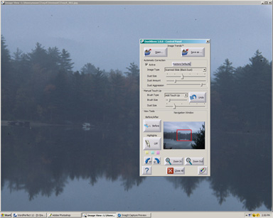
Figure 1 shows the dust and debris on a scanned Kodachrome slide taken in October 1970. The little black spots are dust on the image.

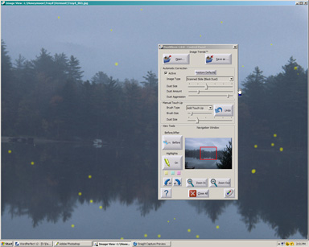
Figure 2 shows the image after automatic dust and debris removal. The dust and debris are highlighted in yellow. As you can see there was a lot of dust on this image. Finally,

Figure 3 shows the final image in Adobe Photoshop CS after the file has cleaned.
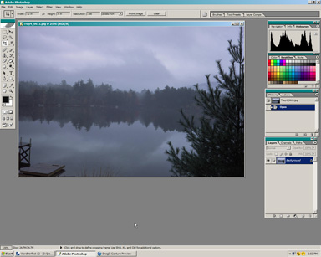

People do not want to spend a lot of time in front of a computer screen correcting scanned images. Cleaning up visible defects from scanned images takes time. I actually tried cleaning up some of these scanned images by hand using the healing brush in Adobe Photoshop CS. Guess what, I didn’t come close to getting all the spots. I then ran the my supposedly cleaned up image through DustKleen. DustKleen found a lot more dust. This dust and debris was visible in the final print. DustKleen is an easy to use stand alone application that works and solves the problem! Question: Why not just use the “remove dust and scratches filter” that’s available in both Adobe Photoshop and Elements? I tried this method as well but found that the image quality was degraded.
Scanning and removing visible dust and defects Kodachrome slides is no easy job. I scanned the Kodachrome slides with a Minolta Dimage Scan Elite 5400. This scanner supports Kodak’s hardware Digital Ice. Digital Ice is a terrific hardware solution. However, Digital Ice does not work with Kodachrome slides or black and white negatives. Even if Digital Ice did work on Kodachrome slides, it still takes approximately seven minutes to scan a slide at 2700 dpi and to clean up dust and debris. Digital Ice works great on E6 processed slides and color negative film but is time consuming. By comparison, scanning four slides at 2700 dpi without Digital Ice takes about five and a half minutes. Cleaning up and saving the four scanned slides using DustKleen takes another minute.

Hint: Scan and save your files as PSD or TIFF. Then run DustKleen to clean up the file and save the file. When you want to make prints convert the files to JPEG and upload them to your favorite photo lab or print them on your own inkjet printers. Remember you do not lose any information when you save a file as a PSD or TIFF.

Conclusion
Every photographer, amateur or professional needs a “digital toolbox” to solve specific problems quickly. In my opinion, DustKleen is a very innovative working tool that should be in every digital photographers digital toolbox. Yes, most of us are now using digital cameras but there is still a sea of prints, negatives and slides that many end users want to convert to a digital format.

DustKleen worked great for me on scanned prints, color negatives, really old black and white Tri-X negatives, E6 processed slides and Kodachrome slides. In every case, there was dust that was not readily visible to the eye or with a loupe. The best part, was I now have some very nice prints made from Kodachrome slides.

DustKleen is a product that needs to be used to really appreciate just how good it is. Be sure to visit and download the trial version for yourself. This is a very impressive innovative product that works.

Recommended Improvements
Not every piece of software is perfect on the first release, but DustKleen is very good. I would make a couple of changes to further improve the workflow. First, I would leave the Image Type to the last image type used, for example, scanned slide (black dust). More than likely the end user will be scanning images from the same format for some time and it’s tiresome to keep changing from the default to the image type that is being scanned. When the end user changes the format he or she will change to the correct Image Type. The second change I would make would be in Save As. It would be great to just click on Save As and automatically have a user defined prefix added to the front of the open file name. For example, if the open image is named Tray1_025.jpg, the Save As image could be named automatically using the user defined prefix DK to DKTray1_025.jpg. Also, by default I would use the highest quality setting for JPEG images. Finally, Adobe’s DNG universal RAW file format should be considered to be added to list of supported file formats.

Neil’s rating (* * * * * – five stars) plus 

Contact
Image Trends Inc.
1 - 512 - 637 - 7300

Note: I would also like to thank the kind folks at Image Trends Inc. for providing me a copy of the DustKleen for review.

This article has been provided to APCUG by the author solely for publication by APCUG member groups. All other uses require the permission of the author (see e-mail address above).

